1. **ReactJS-HOL**

**App.js:**

import './App.css';

*function* App() {

  return (

    <div className="App">

      <h1>Welcome to the First Session of React</h1>

    </div>

  );

}

export default App;

**Output:**

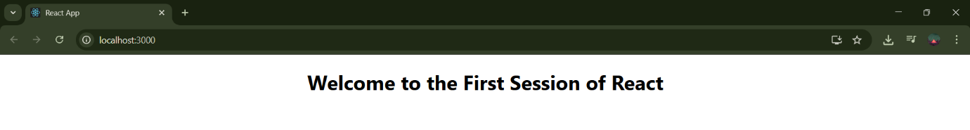

1. **ReactJS-HOL**

**App.js:**

import './App.css';

import Home from './Components/Home';

import About from './Components/About';

import Contact from './Components/Contact';

function App() {

return (

<div className="App">

<Home />

<About />

<Contact />

</div>

);

}

export default App;

**Home.js:**

import React from "react";

*function* Home() {

    return <div><h1>Welcome to the Home Page of the Student Management Portal</h1></div>

}

export default Home;

**About.js:**

import React from "react";

*function* About() {

    return <div><h1>Welcome to the About Page of the Student Management Portal</h1></div>

}

export default About;

**Contact.js:**

import React from "react";

function Contact() {

return <div><h1>Welcome to the Contact Page of the Student Management Portal</h1></div>

}

export default Contact;

**Output:**

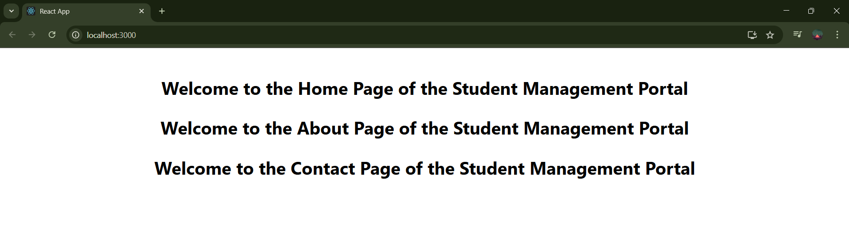

1. **ReactJS-HOL**

**App.js:**

import React from "react";

import CalculateScore from "./Components/CalculateScore";

function App() {

return (

<div className="App">

<CalculateScore total={389} goal={500} />

</div>

);

}

export default App;

**CalculateScore.js:**

import React from "react";

import "../Stylesheets/mystyle.css";

function CalculateScore(props) {

const average = ((props.total / props.goal) * 100).toFixed(2);

return (

<div className="container">

<h2 className="heading">Student Details:</h2>

<p className="Name"><span className="Name">Name: </span>Pranav</p>

<p className="Sname"><span className="Sname">School:</span> SJSV SCHOOL</p>

<p className="Total"><span className="Total">Total:</span> 389 Marks</p>

<p className="Score"><span className="Score">Score:</span> {average}%</p>

</div>

);

}

export default CalculateScore;

**mystyles.css:**

.heading {

  color: brown;

  text-align: center;

  font-size: 30px;

  font-weight: bold;

}

.Name {

  color: blue;

  font-weight: bold;

}

.Sname {

  color: violet;

  font-weight: bold;

}

.Total {

  color: red;

  font-weight: bold;

}

.Score {

  color: green;

  font-weight: bold;

}

.container {

  text-align: center;

  margin-top: 50px;

  font-size: 20px;

}

**Output:**

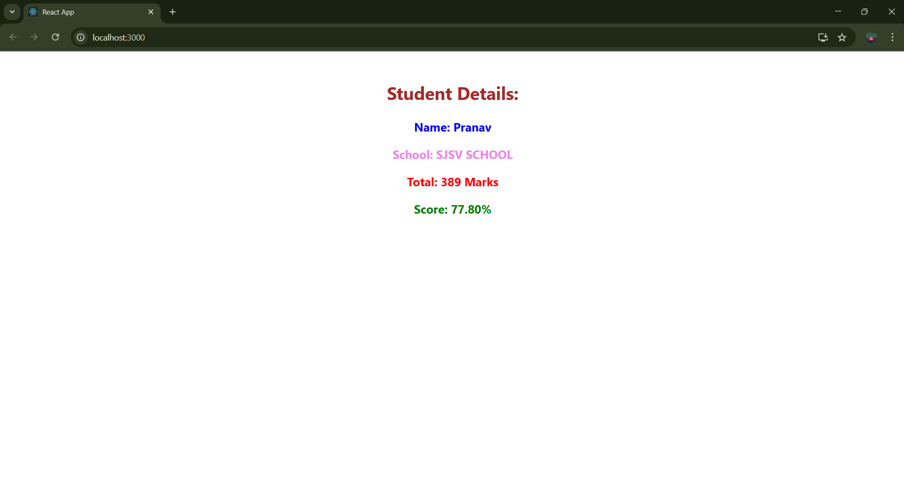

**4. ReactJS-HOL**

**App.js**

import React from 'react';

import './App.css';

import Posts from './Posts';

*function* App() {

  return (

    <div className="App">

      <*Posts* />

    </div>

  );

}

export default App;

**Post.js**

import React from 'react';

*class* Post extends React.Component {

  render() {

    return (

      <div style={{ border: '1px solid #ccc', margin: '10px', padding: '10px' }}>

        <h2>{this.props.title}</h2>

        <p>{this.props.body}</p>

      </div>

    );

  }}

export default Post;

**Posts.js:**

import React from 'react';

import Post from './Post';

*class* Posts extends React.Component {

*constructor*(*props*) {

    super(*props*);

    this.state = {

      posts: [],

      error: null

    };

  }

  loadPosts = async () *=>* {

    try {

*const* response = await fetch('https://jsonplaceholder.typicode.com/posts');

*const* data = await response.json();

      this.setState({ posts: data });

    } catch (err) {

      this.setState({ error: err });

    }

  };

  componentDidMount() {

    this.loadPosts();

  }

  componentDidCatch(*error*, *info*) {

    alert('An error occurred: ' + *error*.toString());

  }

  render() {

    return (

      <div>

        <h1>Blog Posts</h1>

        {this.state.posts.map((*post*) *=>* (

          <*Post* key={*post*.id} title={*post*.title} body={*post*.body} />

        ))}

      </div>

    );

  }

}

export default Posts;

**Output:**

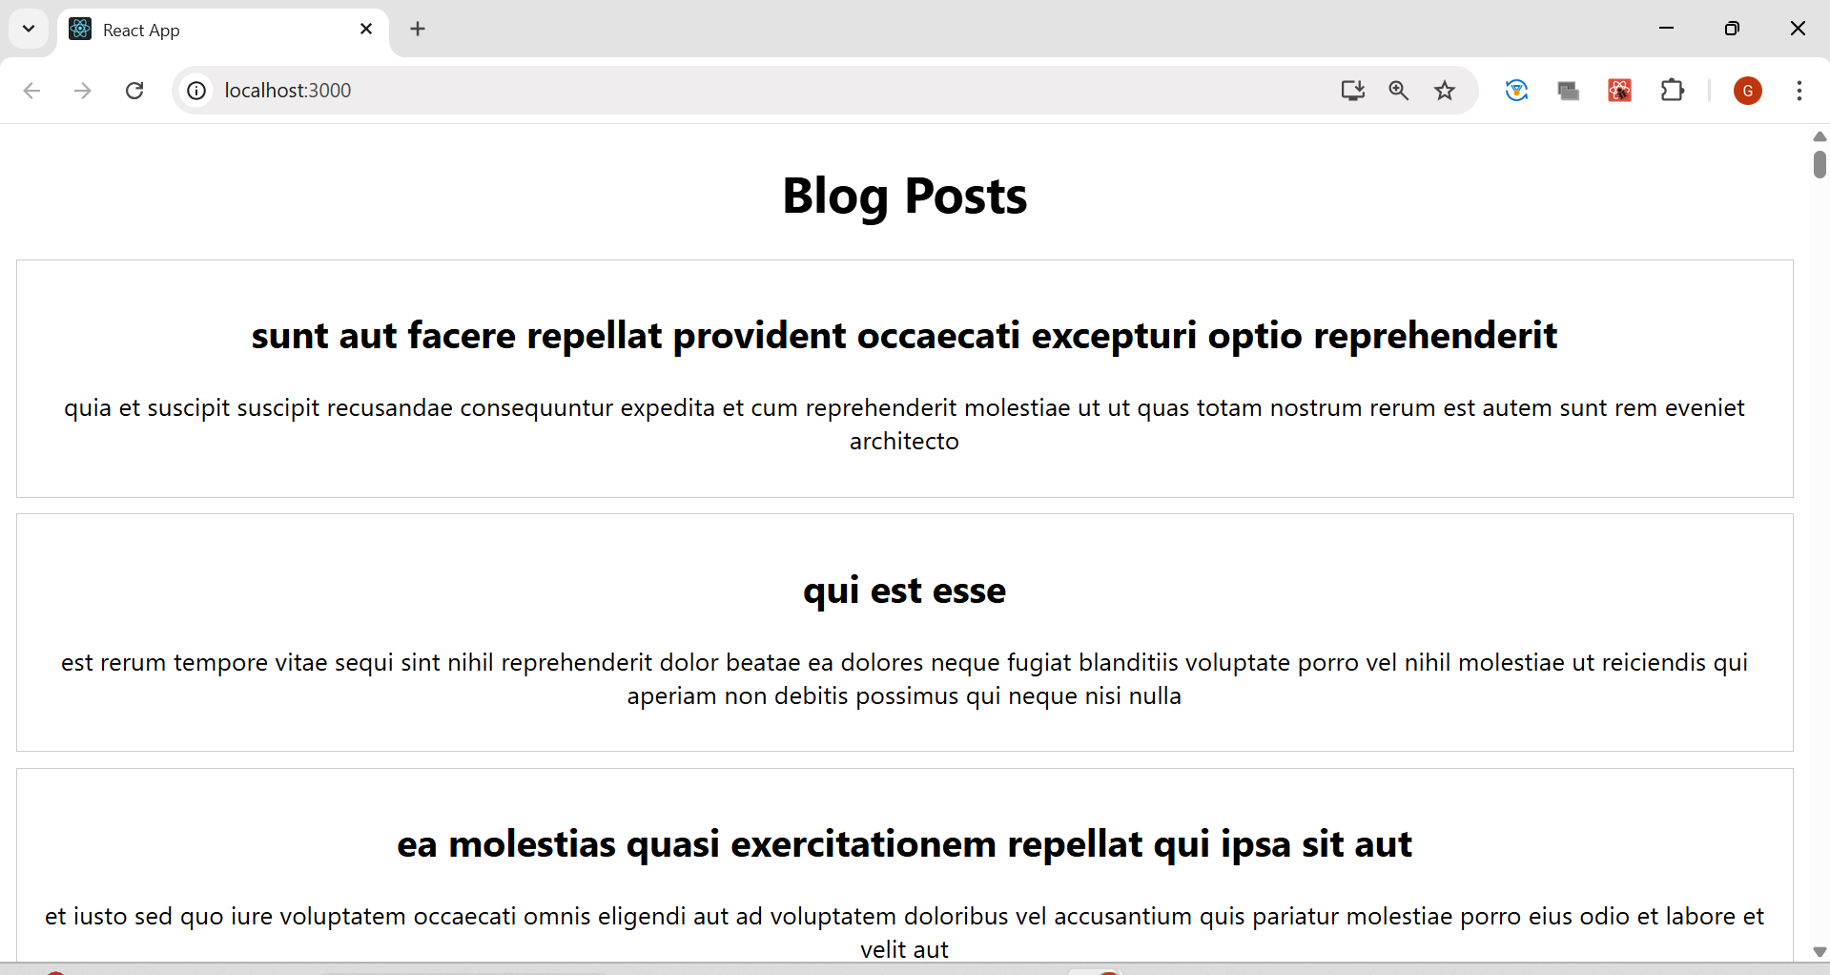

**5. ReactJS-HOL**

**App.js:**

import React from 'react';

import './App.css';

import CohortDetails from './CohortDetails';

*function* App() {

*const* cohorts = [

    {

      name: 'INTADMDF10 - .NET FSD',

      startDate: '22-Feb-2022',

      status: 'Scheduled',

      coach: 'Aathma',

      trainer: 'Jojo Jose'

    },

    {

      name: 'ADM21JF014 - Java FSD',

      startDate: '10-Sep-2021',

      status: 'Ongoing',

      coach: 'Apoorv',

      trainer: 'Elisa Smith'

    },

    {

      name: 'CDBJF21025 - Java FSD',

      startDate: '24-Dec-2021',

      status: 'Ongoing',

      coach: 'Aathma',

      trainer: 'John Doe'

    }

  ];

  return (

    <div style={{ border: '1px solid black', padding: '20px' }}>

      <h1>Cohorts Details</h1>

      {cohorts.map((*cohort*, *index*) *=>* (

        <*CohortDetails* key={*index*} cohort={*cohort*} />

      ))}

    </div>

  );

}

export default App;

**CohortDetails.js:**

import React from 'react';

import styles from './CohortDetails.module.css';

*function* CohortDetails({ *cohort* }) {

*const* { name, startDate, status, coach, trainer } = *cohort*;

*let* headingStyle = {};

  if (status === 'Scheduled') {

    headingStyle.color = 'blue';

  } else if (status === 'Ongoing') {

    headingStyle.color = 'green';

  }

  return (

    <div className={styles.box}>

      <h3 style={headingStyle}>{name}</h3>

      <dl>

        <dt>Started On</dt>

        <dd>{startDate}</dd>

        <dt>Current Status</dt>

        <dd>{status}</dd>

        <dt>Coach</dt>

        <dd>{coach}</dd>

        <dt>Trainer</dt>

        <dd>{trainer}</dd>

      </dl>

    </div>

  );

}

export default CohortDetails;

**CohortDetails.css:**

.box {

width: 300px;

display: inline-block;

margin: 10px;

padding: 10px 20px;

border: 1px solid black;

border-radius: 10px;

background-color: white;

vertical-align: top;

}

dt {

font-weight: 500;

}

**Output:**

